Date Request: 2012-06-20
Date Deployed: 2012-07-02

Pack Entry – add instruction field 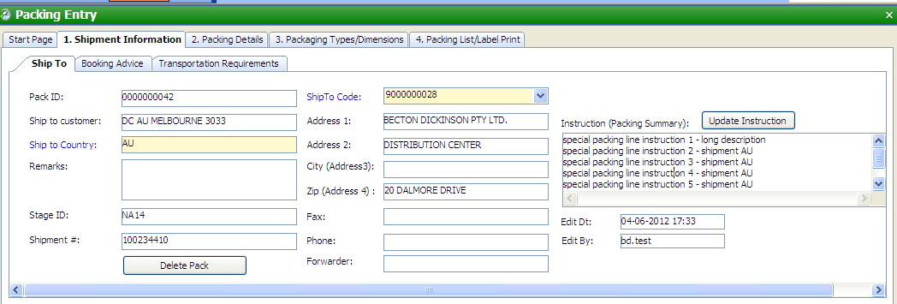

Steps:
- Click On [Update Instruction]
- input instructions
- Click [Save Instruction]
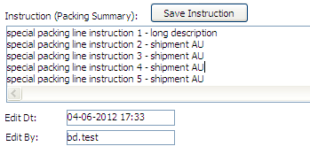

- Go to Tab 4. Packing list , to print packing list with instruction
